Component | Voltage (V) | Current (mA) | Power(mW)
V_{dc} | 5V | 2.5mA | 12.5mW
R1 | 2.5V | 2.5mA | 6.25mW
R2 | 2.5V | 1.25mA | 3.125mW
R3 | 1.25V | 1.25mA | 1.563mW
R4 | 1.25V | 0.625mA | 0.781mW
R5 | 0.625V | 0.625mA | 0.391mW
R6 | 0.625V | 0.313mA | 0.196mW
R7 | 0.3125V | 0.313mA | 0.0978mW
R8 | 0.3125V | 0.313mA | 0.0978mW
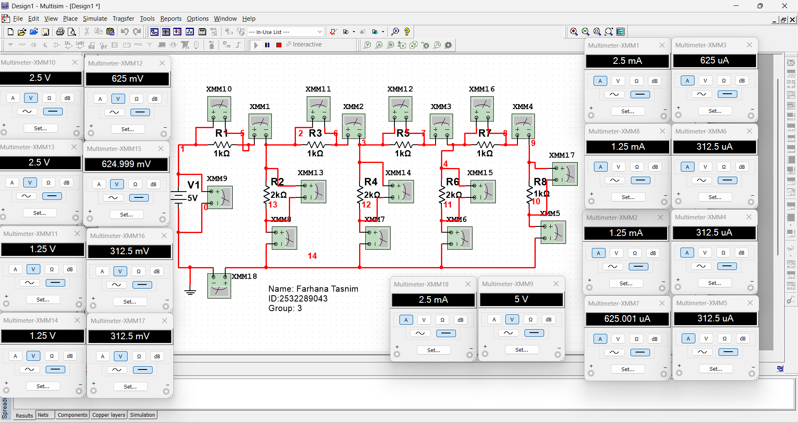
Name:Farhana Tasnim
ID: 2532289043 Group:3

